UNIT 3 PRACTICE TEST Name:

1) The local police, using radar, checked the speeds (in mph) of 30 motorists in a construction area. The results are listed below. Construct a histogram:
Speed | Frequency
33-35 | 3
36-38 | 6
39-41 | 6
42-44 | 6
45-47 | 3
48-50 | 6
2) Find the mean, median, and mode of the following statistic students' test scores:

95 98 91 95 88 96 95 89 90 93
3) The heights of ten female students (in inches) in a college math class are listed below. Find the mean:

65 66 67 66 67 70 67 70 71 68
A) 65.5 inches B) 70.0 inches C) 71.1 inches D) 67.7 inches
4) The number of students enrolled in a physics class for the last ten semesters are listed below. Find the median number of students:
65 66 67 66 67 70 67 70 71 68
A) 66 students B) 70 students C) 67 students D) 68 students

5) The commuting times of ten employees (in minutes) are listed below. Find the mode score:

65 66 67 66 67 70 67 70 71 68
A) 65 minutes B) 67 minutes C) 68 minutes D) 66 minutes
6.) Compute the range for the set of data.
63 136 18 91 193

A) 175 B) 100.2 C) 18 D) 193
7.) Find the standard deviation.
38 85 61 64 53 39 27 34
A) 18.0 B) 8 C) 50.1 D) 17.6
8) Which distribution varied the most? Use standard deviation.
A) 2 B) 7 C) 10.5 D) 3
9) A school asked a small number of students to test two typing programs. At the end of the trial, all students in a group had different typing speeds. There were 21 students using program A and 24 students using program B. The results are shown in the box plots.
Typing Speeds

Program A

Program B

20 30 40 50 60 70
Words per Minute

The school compared the time results of program A against the time results of program B. More program B students had typing speeds less than or equal to 33 words per minute. How many more?

A) 13 B) 5 C) 3 D) 8

10) A group of 79 students were asked how far they commute to work from home each time they go to work from home. The results are given below. Would a drive of 15 miles be considered an outlier?
Answer yes or no. (SEE TABLE ON THE BOARD)

11) A chemist is analyzing aluminum samples. The percentages of copper in several samples are shown below.
4.4%, 4.3%, 4.7%, 4.1%, 3.8%, 4.7%, 4.1%, 4.8%, 2.3%
Which box plot represents this data?

[A]

2% 3% 4% 5%

Percent of Copper

[B]

2% 3% 4% 5%

Percent of Copper

[C]

2% 3% 4% 5%
Percent of Copper

12) A random sample of sale prices of homes yielded the following summary information:

MIN $48,000 | 25%: $83,000 | Median: $129,000
MAX $270,000 | 75%: $160,000
Comment on a home that had a sale price of $419,000:
A) This value falls outside of the third quartile, but cannot be considered an outlier.
B) This sale price falls between the lower and upper fences. It can be considered a potential outlier.
C) This sale price would be expected since it falls inside the lower and upper fences.
D) This value falls outside the upper fence and is considered an outlier.

13) The test scores of 30 students are listed below. Draw a boxplot that represents the data:
31 | 41 | 45 | 48 | 52 | 55 | 56 | 56 | 63 | 65
67 | 67 | 69 | 70 | 70 | 74 | 75 | 78 | 79 | 79
80 | 81 | 83 | 85 | 85 | 87 | 90 | 92 | 95 | 99

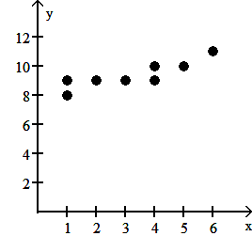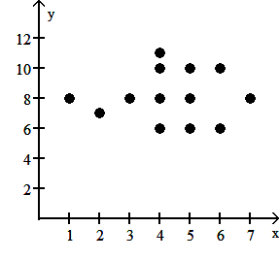
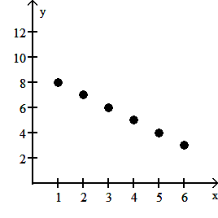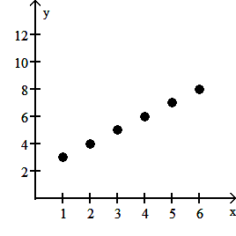
14) In which scatter diagram is r = 1? Circle the correct graph.
15) A researcher determines that the linear correlation coefficient is 0.88 for a paired data set. This indicates that there is
A) no linear correlation but that there may be some other relationship.
B) a strong negative linear correlation.
C) insufficient evidence to make any decision about the correlation of the data.
D) a strong positive linear correlation.
16.) Compute the linear correlation coefficient between the two variables and determine whether a linear relation exists
A) r = -0.335; no linear relation exists B) r = -0.335; linear relation exists
C) r = -0. 284; no linear relation exists D) r = 0.462; linear relation exists

17) Find the equation of the regression line for the given data. Round values to the nearest thousandth.

-5 | -3 | 4 | 1 | -1 | -2 | 0 | 2 | 3 | -4
11 | 6 | -6 | -1 | 3 | 4 | 1 | -4 | -5 | 8
A) y = -1.885x + 0.758 B) y = 1.885x – 0.758
C) y = -0.758x – 1.885 D) y = 0.758x + 1.885

18) The one-way distances from work (in miles) of 30 employees are listed below. Find the interquartile range (IQR) of the 15 distances listed below:
25 25 26 27 27.5 28 28 28.5 29 30.5 32 33.5 35 35 37

19) The payroll amounts for 26 major-league baseball teams are shown below. Approximately what percentages
of the payrolls were in the $30-$40 million range? Round to the nearest whole percent:
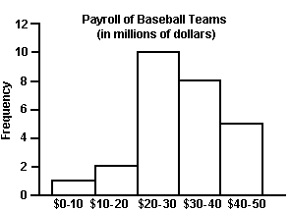
A) 31% B) 8% C) 19% D) 42%

20) Given the equation of a regression line is y= 2x - 9, what is the best-predicted value for y given x = 3?
A) -4 B) -3 C) 25 D) 15

